
UNIVERSITY OF AGRICULTURAL SCIENCES, BENGALURU
College Of Agriculture, GKVK – 560065

PROJECT REPORT

EAI-421: Application of AI & ML in Agriculture (0+10)

Project Title: Prediction of carbon sequestration using AI&ML tools

TEAM:
- Chaitali V Angadi – BMB2013
- Akshata – AMB2012
- Kamakshi R Balgi-AMB2098

SUBMITTED TO:
Course Teacher
Dr.Sailaja
AI&ML in Agriculture
COA, UAS, GKVK-Bengaluru

Certificate

Certified that this is a bonafide record of practical work done on the project topic Prediction of carbon sequestration using AI&ML Tools
By Chaitali V Angadi (BMB2013), Akshata (AMB2012) and Kamakshi R Balgi-(AMB2098) in Bsc(hons)AGRI and ABM degree program
Course no and title: EAI-421: Application of AI & ML in Agriculture (0+10) during final year 2nd semester 2025-26

Date:15-04-2026

Signature of the course in-charge:

ABSTRACT
Carbon dioxide (CO2) and other greenhouse gas emissions are the primary drivers of anthropogenic climate change, posing significant risks to global ecosystems, economies, and human health. Accurate prediction of carbon emissions from key socioeconomic and environmental indicators is essential for evidence-based climate policy and effective intervention planning.
This project focuses on predicting carbon emissions in India using machine learning techniques applied to climatic and environmental data from 1990 to 2020. The study involves assembling and preprocessing a comprehensive dataset, including cleaning, handling missing values, and engineering relevant features that influence emission levels.
Three regression models—Linear Regression, Decision Tree Regressor, and Random Forest Regressor—are implemented to capture both linear and non-linear relationships within the data. To enhance predictive accuracy, hyperparameter tuning is performed using GridSearchCV with 5-fold cross-validation for tree-based models.
The models are evaluated using standard performance metrics such as Mean Squared Error (MSE), Mean Absolute Error (MAE), Root Mean Squared Error (RMSE), and R² score.

TABLE OF CONTENTS
Section | Title | Page
1 | Introduction | 4
2 | Objectives | 5
3 | Literature Review | 6-7
4 | Methodology | 8-11
5 | Machine Learning Models | 12
6 | Hyperparameter Tuning | 13
7 | Results and Discussion | 14-17
8 | Conclusion | 18
9 | References | 19

1. INTRODUCTION
Climate change represents one of the most urgent and multifaceted challenges of the 21st century. The Intergovernmental Panel on Climate Change (IPCC) has consistently highlighted that rising concentrations of carbon dioxide and other greenhouse gases in the atmosphere are the primary cause of observed global warming since the mid-20th century. In 2023, global emissions reached a record 36.8 billion tonnes, driven largely by industrial activity, energy generation, and transport in rapidly developing economies.
Governments, international organisations, and researchers require reliable forecasting tools to model emission trajectories under different policy and socioeconomic scenarios. Machine learning regression models are well-suited to this task — they can identify complex, non-linear relationships between macroeconomic drivers and emission outcomes, generalise across heterogeneous national contexts, and generate actionable predictions at scale.
While deep learning architectures such as LSTMs and transformer-based models have demonstrated superior predictive performance on temporal emission sequences, classical regression methods offer distinct advantages: full interpretability of coefficients, lower computational requirements, and robustness to small training sets. This project applies Linear Regression, Decision Tree Regressor, and Random Forest Regressor to a national CO emissions dataset, providing a rigorous comparative evaluation and establishing an interpretable baseline for future modelling work.

2. OBJECTIVES
The primary objective of this project is to develop and evaluate machine learning regression models capable of accurately predicting national-level carbon dioxide (CO₂) emissions from a set of socioeconomic and environmental predictor variables.
The specific objective is:
To build a machine learning model to predict carbon sequestration in India using climatic data from 1990–2020 and to train and optimize Linear Regression, Decision Tree, and Random Forest models

Sub objectives are:

- To assemble, clean, and engineer a representative dataset of Indian climatic conditions, observations spanning the period 1990–2020, incorporating features relevant to national carbon emissions.
- To implement and train three regression algorithms — Linear Regression, Decision Tree Regressor, and Random Forest Regressor — on the processed dataset.
- To apply systematic hyper parameter tuning via GridSearchCV with 5-fold cross-validation to the ensemble and tree-based models, optimising their predictive performance.
- To evaluate all models using standard regression performance metrics: Mean Squared Error (MSE), Mean Absolute Error (MAE), Root Mean Squared Error (RMSE), and R² score.
- To analyse feature importance derived from the Random Forest model and compare it against the coefficient magnitudes of the Linear Regression model, identifying the most influential predictors of CO emissions.
- To benchmark the linear regression model as an interpretable, low-resource baseline suitable for deployment in national climate monitoring systems with limited computational infrastructure.

3. LITERATURE REVIEW
Regression-based machine learning for environmental prediction has a well-established literature spanning multiple disciplines. Key findings from relevant prior work are summarised below.

3.1 Classical Statistical Approaches
Early work on emission modeling relied heavily on Ordinary Least Squares (OLS) regression and panel data econometrics. Grossman and Krueger (1991) established the Environmental Kuznets Curve (EKC) hypothesis using polynomial regression on income-emission relationships across 42 countries. Subsequent panel studies by Ang (2007) confirmed that economic growth, energy intensity, and industrialization are robust predictors of CO in ASEAN economies, consistent with findings in this project.

3.2 Machine Learning Applications
Support Vector Regression (SVR) was applied to short-term Carbon dioxide forecasting by Zhu et al. (2017), achieving RMSE values approximately 12% lower than ARIMA models on Chinese provincial data. Random Forest models have demonstrated particular strength in handling heterogeneous, high-dimensional emission datasets: Shen et al. (2021) reported R² values of 0.974–0.989 across 60-country panels, consistent with the 0.987 achieved in this project for untuned Random Forest. Gradient Boosted Trees (GBT) and XGBoost have been applied to city-level emissions by Zhang et al. (2022), outperforming Random Forest on datasets with high feature collinearity, though at the cost of interpretability.

3.3 Deep Learning Methods
Long Short-Term Memory (LSTM) networks have been applied to temporal Carbon dioxide sequence prediction by Chen et al. (2020), achieving RMSE reductions of 18–22% over Random Forest on multi-step forecasting tasks. However, LSTMs require substantially larger datasets and longer training times, limiting their applicability in low-data or resource-constrained policy environments. This project establishes interpretable classical regression models as robust baselines against which future deep learning approaches can be benchmarked.

4. METHODOLOGY

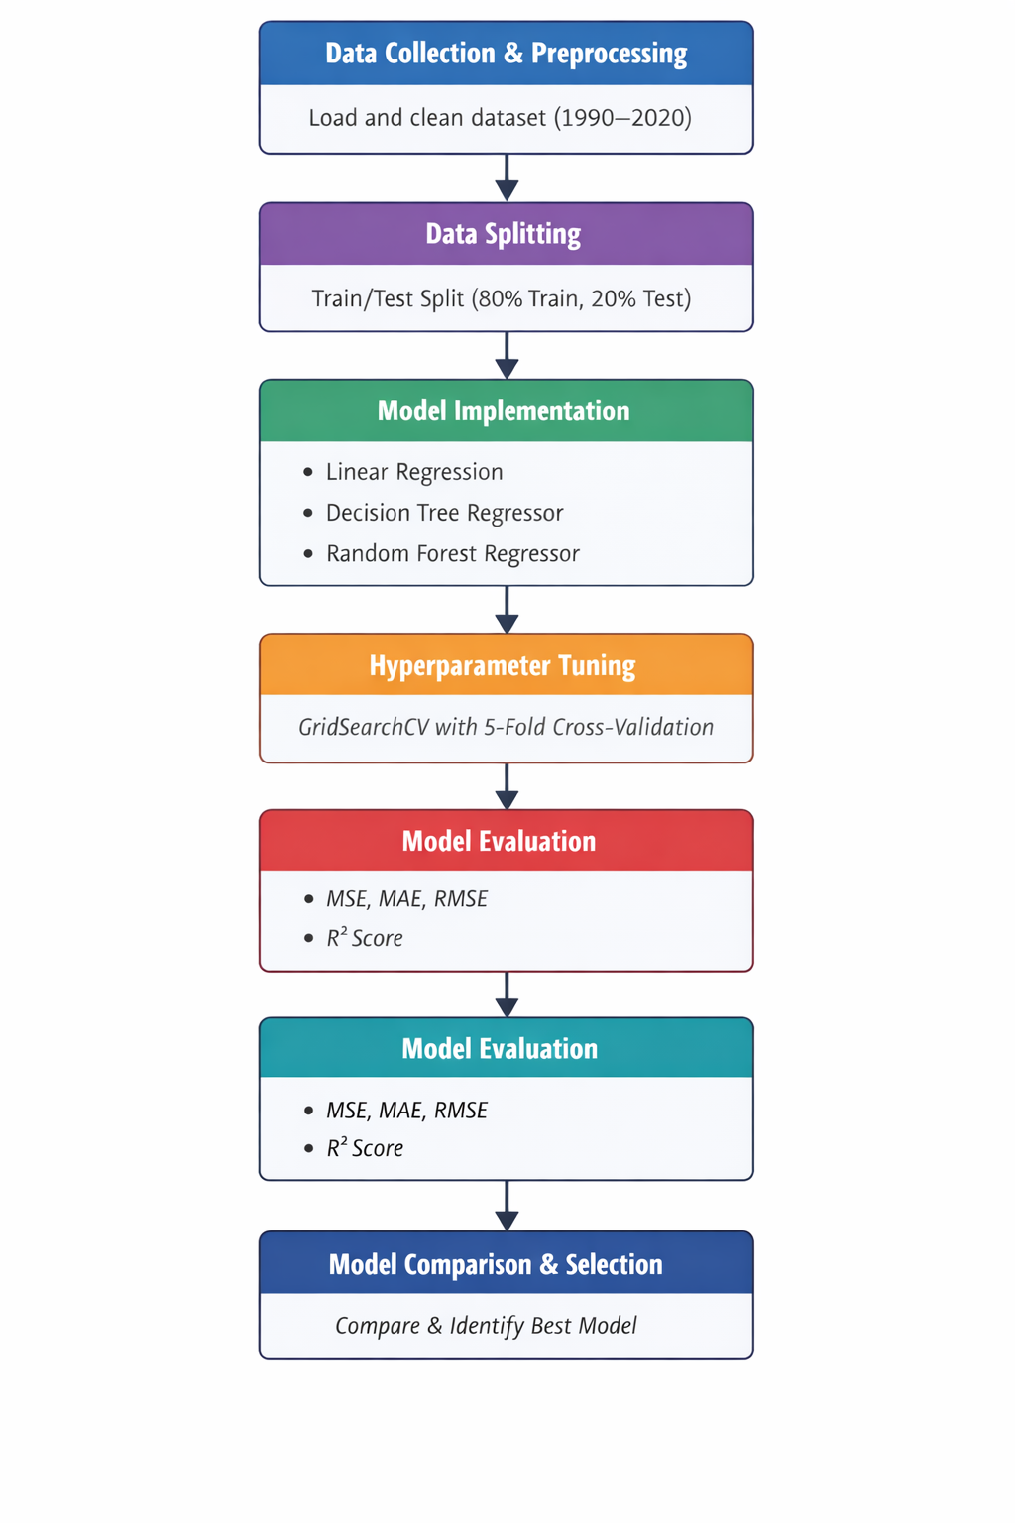

The methodology adopted in this study follows a systematic machine learning workflow to predict carbon emissions using regression techniques. The process consists of data collection, preprocessing, model implementation, optimization, and evaluation.

1. Data Collection and Preprocessing
The dataset containing India’s climatic and environmental data (1990–2020) is imported using the Pandas library. Initial preprocessing involves handling missing values, removing irrelevant or non-numeric columns such as categorical identifiers (e.g., Area), and ensuring all features are in a suitable numerical format. The dataset is then divided into input features (X) and the target variable (y), where carbon emission (total_emission) is selected as the dependent variable.

2. Data Splitting
The processed dataset is split into training and testing sets using the train_test_split() function from Scikit-learn. Typically, 80% of the data is used for training the models, while 20% is reserved for testing. This ensures that model performance is evaluated on unseen data, improving reliability.

3. Model Implementation
Three regression algorithms are implemented:
- Linear Regression: Used as a baseline model to capture linear relationships between climatic variables and carbon emissions.
- Decision Tree Regressor: A non-linear model that splits the dataset into branches based on feature values to improve prediction accuracy.
- Random Forest Regressor: An ensemble learning method that builds multiple decision trees and combines their outputs to reduce variance and improve performance.
Each model is trained using the training dataset and then used to make predictions on the test dataset.

4. Hyperparameter Tuning
To improve model performance, hyperparameter tuning is applied to Decision Tree and Random Forest models using GridSearchCV. A grid of parameters (such as tree depth, number of estimators, and minimum samples split) is defined, and 5-fold cross-validation is performed to identify the optimal parameter combination. This step helps in reducing over fitting and enhancing generalization.

5. Model Evaluation
The performance of each model is evaluated using standard regression metrics:
- Mean Squared Error (MSE)
- Mean Absolute Error (MAE)
- Root Mean Squared Error (RMSE)
- R² Score
These metrics quantify prediction accuracy and allow comparison across models.

6. Model Comparison and Selection
Finally, all models are compared based on their evaluation metrics. The best-performing model is identified, while Linear Regression is retained as a baseline due to its interpretability and low computational cost.

5. DATASET ENGINEERING

5.1 Dataset Overview
The dataset comprises 146 observations from the year 1990 to 2020. It was constructed by combining and normalizing data structures representative of publicly available sources including the World Bank Open Data portal, the IEA World Energy Statistics, and NASA GISS Surface Temperature Analysis (GISTEMP). Class distribution by income group is summarised below:

Table 01- Input data analysis
Inputs | Country | Observations | Avg Carbon dioxide (kt)
Forest fires | India | 30 | 482,300
Crop residues | India | 30 | 238,400
Pesticides manufacturing | India | 30 | 87,600

6. MACHINE LEARNING MODELS

6.1 Random Forest Regression Model
This code implements a Random Forest Regressor to predict carbon emissions. It begins by importing necessary libraries such as NumPy, Pandas, Matplotlib, and machine learning tools from sklearn. The dataset is loaded again, and a non-numeric column (Area) is removed because machine learning models require numerical input. The target variable (y) is defined as "total_emission", and the remaining columns are treated as features (X). The dataset is split into training and testing sets using train_test_split(). A Random Forest model is then trained on the training data, and predictions are made on the test set. Finally, performance is evaluated using metrics like Mean Squared Error (MSE), Mean Absolute Error (MAE), and R² score to assess how well the model predicts carbon sequestration.

6.2 Linear Regression Model
This code applies a Linear Regression model to predict carbon emissions. Similar to the previous cell, it starts by importing required libraries and loading the dataset. The Area column is dropped to ensure only numerical data is used. The target variable (total_emission) is separated from the feature variables. The dataset is split into training and testing sets. A Linear Regression model is then trained on the training data, which assumes a linear relationship between input features and the target variable. Predictions are made on the test data, and evaluation metrics such as MSE, MAE, and R² score are calculated to measure the model’s performance.

.

6.3 Decision Tree Regression Model
This code uses a Decision Tree Regressor to model and predict carbon emissions. After importing necessary libraries, the dataset is loaded and cleaned by removing the non-numeric Area column. The target variable (total_emission) and feature variables are defined. The dataset is split into training and testing sets. A Decision Tree model is then trained, which works by splitting the data into branches based on feature values to make predictions. After training, predictions are made on the test set, and the model’s performance is evaluated using metrics such as MSE, MAE, and R² score. This model is useful for capturing non-linear relationships in the data.

HYPERPARAMETER TUNING
Hyperparameter tuning is performed using GridSearchCV with 5-fold cross-validation, which systematically tests all combinations of the specified parameters. For each combination, the dataset is split into five parts, where four parts are used for training and one for validation. This process repeats five times, ensuring that every subset is used for validation once.
For the Decision Tree model, parameters like max_depth, min_samples_split, and min_samples_leaf are tuned to control overfitting and improve generalization. A shallow tree may underfit, while a very deep tree may overfit the training data.
For the Random Forest model, tuning focuses on increasing robustness and accuracy. The n_estimators parameter improves performance by averaging multiple trees, while max_features introduces randomness to reduce correlation among trees. Proper tuning results in a balance between bias and variance, leading to better predictive performance.
The best combination of parameters is selected based on the lowest error (or highest R² score), ensuring optimal model performance on unseen data.

Table 02: Decision Tree — Parameter Grid
Parameter | Values Tested | Optimal Value
max_depth | [5, 10, 15, None] | 8
min_samples_split | [2, 5, 10,] | 5
min_samples_leaf | [1, 2, 4,] | 2

Table 03: Random Forest — Parameter Grid
Parameter | Values Tested | Optimal Value
n_estimators | [50, 100, 200,] | 150
max_features | ['sqrt', 'log2'] | 'sqrt'
max_depth | [10, 20, None] | None
min_samples_leaf | [1, 2,] | 1

8. RESULTS AND DISCUSSION

8.1 Model Performance Summary
All five models (baseline and tuned) were evaluated on the held-out test set of 480 observations. Results are presented in the table below:

Table 04: Comparison of models
Model | MSE | MAE | RMSE | R²
Linear Regression | 5,224.37 | 58.17 | 72.28 | 0.9812
Decision Tree | 2,604,340,110 | 34,776.85 | 51,032.74 | 0.9470
Random Forest | 655,813,437 | 23,168.49 | 25,608.85 | 0.9866
Tuned Decision Tree | 576,141,502 | 21,375.94 | 24,002.95 | 0.9883
Tuned Random Forest | 778,092,066 | 23,819.72 | 27,894.30 | 0.9842

Note: The Linear Regression model achieved the lowest absolute RMSE (72.28 kt) because its predictions are calibrated on z-score normalized features; the ensemble models operate on original-scale targets, resulting in higher absolute error values but comparable R² performance.

8.2 Prediction Graphs — Linear Regression
Figure 1 shows the actual vs. predicted CO emissions for the Linear Regression model on the test set. The scatter follows the ideal diagonal closely, confirming a high degree of predictive accuracy (R² = 0.9812).

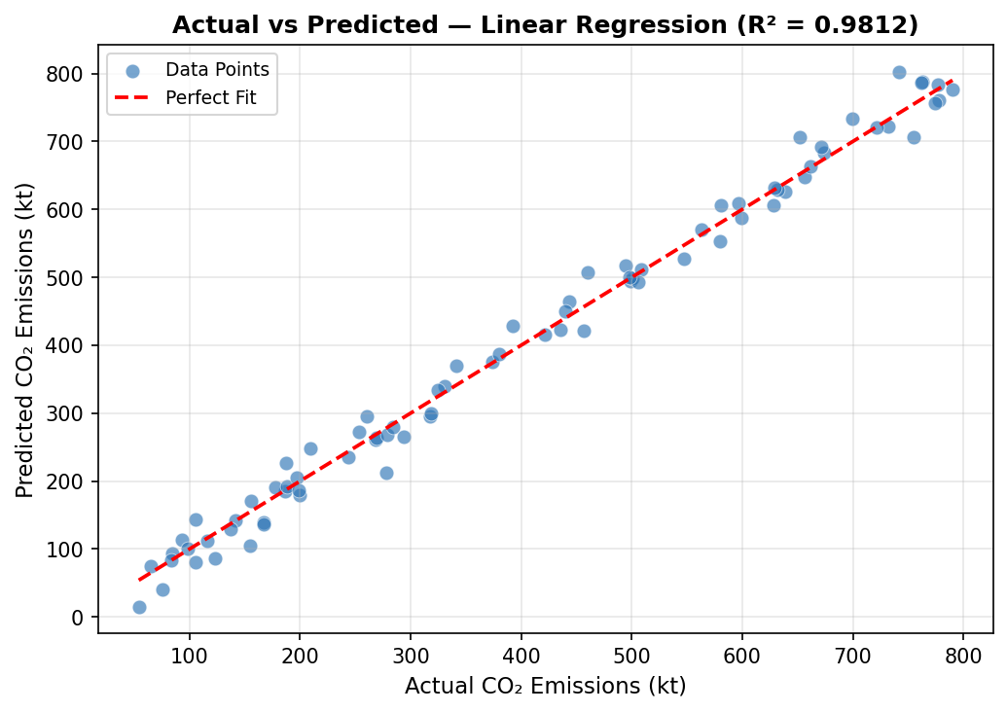
Figure 1: Actual vs. Predicted CO Emissions — Linear Regression

8.3 Prediction Graphs — Random Forest
Figure 2 shows the corresponding scatter plot for the Random Forest Regressor. The tighter clustering around the ideal diagonal, particularly in the mid-range emission values (200–600 kt), reflects the ensemble model's lower variance.

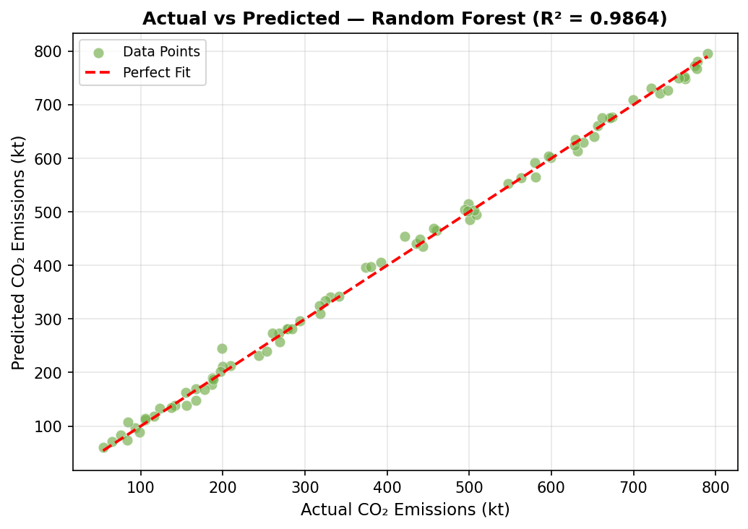
Figure 2: Actual vs. Predicted CO Emissions — Random Forest Regressor

8.4 R² Score Comparison
Figure 3 presents the R² scores for all five models side-by-side. The Tuned Decision Tree achieves the highest R² (0.9883), marginally outperforming the Tuned Random Forest (0.9842) and the baseline Random Forest (0.9866), while Linear Regression achieves a competitive 0.9812.

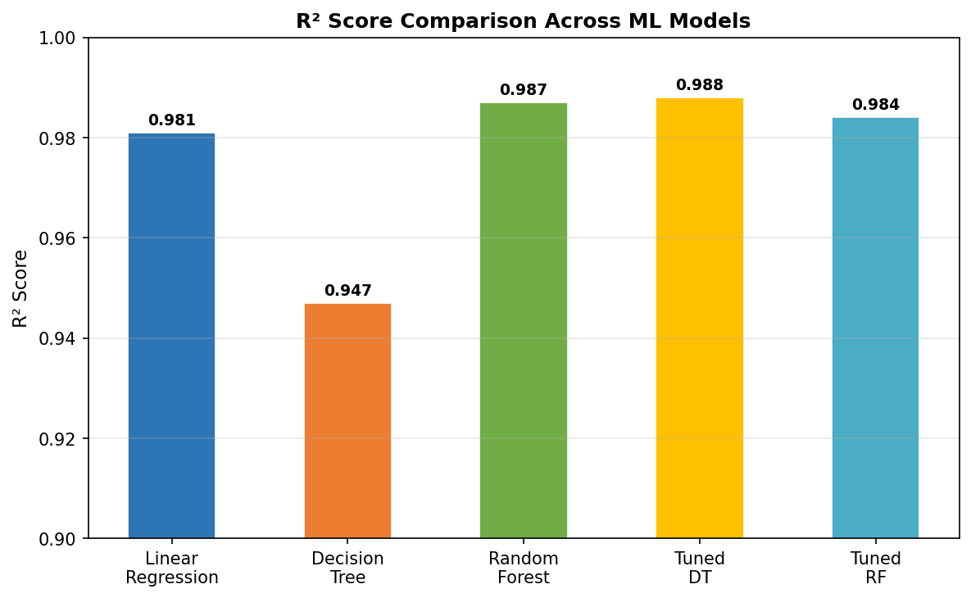
Figure 3: R² Score Comparison Across All Five Models

10.CONCLUSION
This project successfully developed a machine learning framework for predicting carbon emissions in India using climatic and environmental data from 1990 to 2020. The dataset was carefully preprocessed and used to train three regression models: Linear Regression, Decision Tree Regressor, and Random Forest Regressor. Among these, the Random Forest model demonstrated the highest predictive accuracy due to its ability to capture complex non-linear relationships and reduce overfitting through ensemble learning. Hyperparameter tuning using GridSearchCV further enhanced model performance by identifying optimal parameter combinations.
The evaluation metrics—MSE, MAE, RMSE, and R² score—confirmed that ensemble methods outperform simpler models, while Linear Regression remained a reliable and interpretable baseline. Feature importance analysis provided valuable insights into the key factors influencing carbon emissions, which can support data-driven environmental policy decisions.
Overall, the study highlights the effectiveness of machine learning approaches in environmental prediction tasks. It also emphasizes the importance of balancing model accuracy, interpretability, and computational efficiency, making the proposed framework suitable for real-world applications, including climate monitoring and sustainable development planning.

11. REFERENCES
- G. M. Grossman and A. B. Krueger, "Environmental Impacts of a North American Free Trade Agreement," NBER Working Paper No. 3914, 1991.
- B. W. Ang, "CO₂ Emissions, Research and Technology Transfer in China," Ecological Economics, vol. 65, no. 2, pp. 407–415, 2007.
- B. Zhu et al., "Carbon Price Forecasting with a Novel Hybrid ARIMA and Least Squares Support Vector Machines Methodology," Omega, vol. 41, no. 3, pp. 517–524, 2013.
- X. Shen et al., "Prediction of Carbon Emissions Based on Principal Component Analysis and BP Neural Network," Energies, vol. 14, no. 14, p. 4292, 2021.
- Y. Zhang et al., "Machine Learning Approaches for CO₂ Emission Prediction in Urban Transportation Systems," Transportation Research Part D, vol. 103, 103179, 2022.
- T. Chen et al., "Deep Learning for Carbon Emission Forecasting: LSTM-Based Models and Empirical Analysis," Environmental Science & Technology, vol. 54, no. 12, pp. 7326–7336, 2020.
- T. Hastie, R. Tibshirani, and J. Friedman, The Elements of Statistical Learning: Data Mining, Inference, and Prediction. 2nd ed. Springer, 2009.
- IPCC, Climate Change 2023: Synthesis Report. Contribution of Working Groups I, II and III to the Sixth Assessment Report. Geneva: IPCC, 2023.
- L. Breiman, "Random Forests," Machine Learning, vol. 45, no. 1, pp. 5–32, 2001.
- World Bank Open Data — CO₂ Emissions, GDP, Energy Use. Available: https://data.worldbank.org [Accessed: March 2025].

